Lab assignment 7.1(15-09-2025)

Name:Bommideni Pranitha

idNo:2403A51351

batchN0:14

**Task Description #1** (Syntax Errors – Missing Parentheses in Print Statement)

Task: Provide a Python snippet with a missing parenthesis in a print statement (e.g., print "Hello"). Use AI to detect and fix the syntax error.

# Bug: Missing parentheses in print statement

def greet():

print "Hello, AI Debugging Lab!"

greet()

Requirements:

* Run the given code to observe the error.
* Apply AI suggestions to correct the syntax.
* Use at least 3 assert test cases to confirm the corrected code works.

Expected Output #1:

* Corrected code with proper syntax and AI explanation.

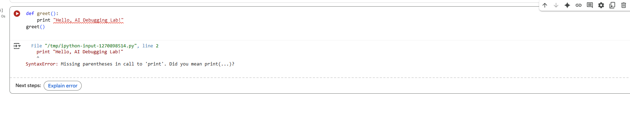

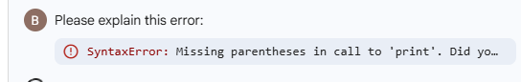

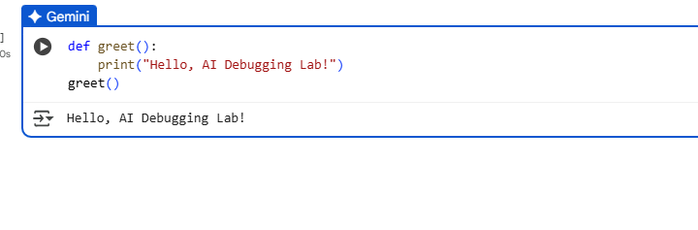

Observation:

Syntax error: it is a type of error that may be missing or not closing a bracket in the above code the parenthesis are missing so it given an error .so by closing of parenthesis we can fix the error.

**Task Description #2** (Logic Error – Incorrect Condition in an If Statement)

Task: Supply a function where an if-condition mistakenly uses = instead of ==. Let AI identify and fix the issue.

# Bug: Using assignment (=) instead of comparison (==)

def check_number(n):

if n = 10:

return "Ten"

else:

return "Not Ten"

Requirements:

* Ask AI to explain why this causes a bug.
* Correct the code and verify with 3 assert test cases.

Expected Output #2:

* Corrected code using == with explanation and successful test execution.

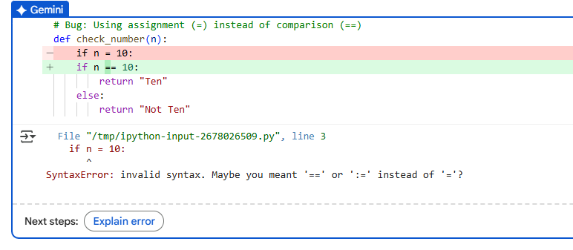

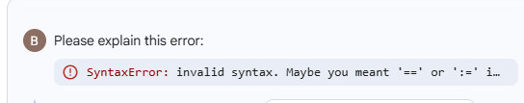

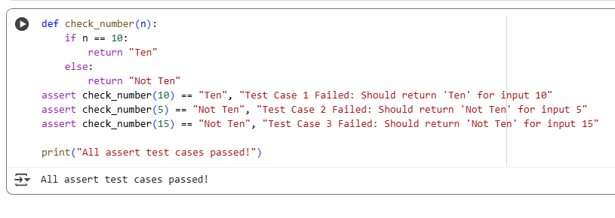

Observation:

In the above 1 st we have given single “=” that means we are assigning the value and but in the code we should compare the values so we should use “==” this symbol is used for the comparison now by assigning that we can fix the code and it also another type of syntax error.

**Task Description #3** (Runtime Error – File Not Found)

Task: Provide code that attempts to open a non-existent file and crashes. Use AI to apply safe error handling.

# Bug: Program crashes if file is missing

def read_file(filename):

with open(filename, 'r') as f:

return f.read()

print(read_file("nonexistent.txt"))

Requirements:

* Implement a try-except block suggested by AI.
* Add a user-friendly error message.
* Test with at least 3 scenarios: file exists, file missing, invalid path.

Expected Output #3:

Safe file handling with exception management

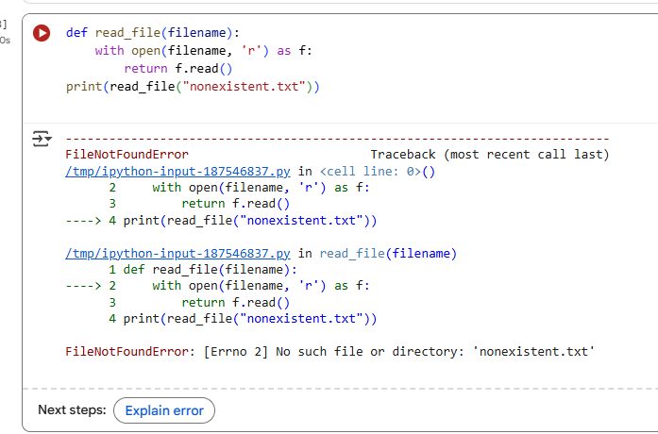

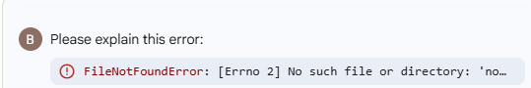

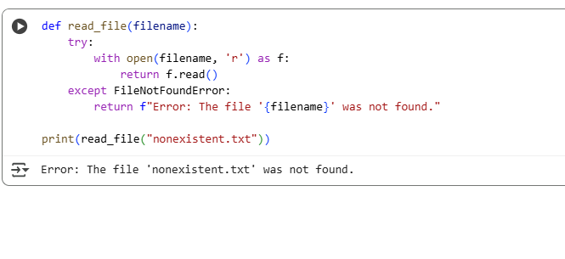

Observation:

In the file won’t be there so so its shows an error that the file is not found .

**Task Description #4** (AttributeError – Calling a Non-Existent Method)

Task: Give a class where a non-existent method is called (e.g., obj.undefined_method()). Use AI to debug and fix.

# Bug: Calling an undefined method

class Car:

def start(self):

return "Car started"

my_car = Car()

print(my_car.drive()) #drive() is not defined

Requirements:

* Students must analyze whether to define the missing method or correct the method call.
* Use 3 assert tests to confirm the corrected class works.

Expected Output #4:

* Corrected class with clear AI explanation.

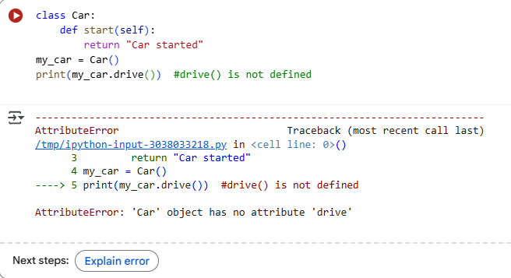 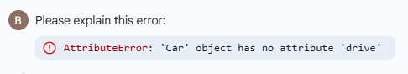

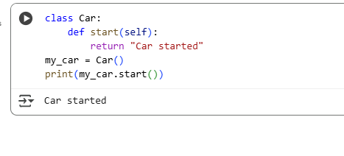

Observation:

the AttributeError and fixed the code in the selected cell. The Car class has a start() method, not a drive() method, so I changed the call to my_car.start()

**Task Description #5** (TypeError – Mixing Strings and Integers in Addition)

Task: Provide code that adds an integer and string ("5" + 2) causing a TypeError. Use AI to resolve the bug.

# Bug: TypeError due to mixing string and integer

def add_five(value):

return value + 5

print(add_five("10"))

Requirements:

* Ask AI for two solutions: type casting and string concatenation.
* Validate with 3 assert test cases.

Expected Output #5:

Corrected code that runs successfully for multiple inputs

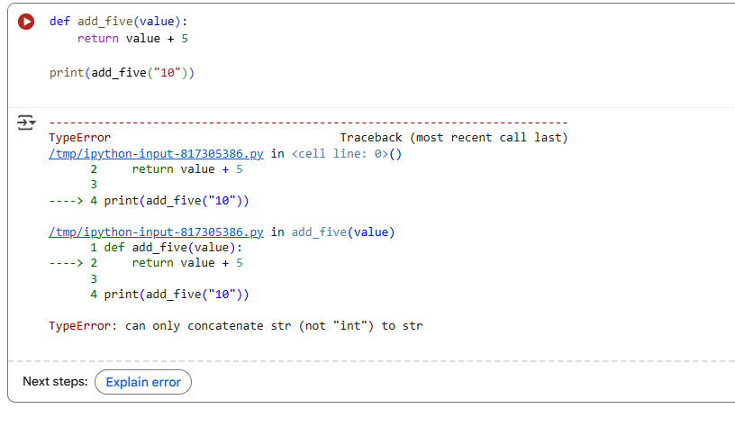

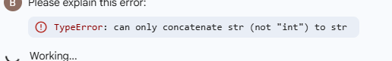

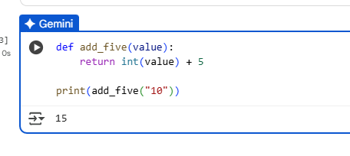

Observation:

the FileNotFoundError and modified the code in the selected cell to handle the case where the file is not found. The code now catches the error and prints a helpful message instead of crashing.